|  |  |
| --- | --- |
| **NAME** | **:**  SANTHOSHKUMAR S |
| **DEPARTMENT** | **:** ELECTRONICS AND COMMUNICATION  ENGINEERING |
| **COLLEGE** | **:** GOVERNMENT COLLEGE OF |

TECHNOLOGY

**NAAN MUDHALVAN COURSE:** DIGITAL MARKETING

**NAAN MUDHALVAN ID :**  665F1696A461B8FB0AA4E1D1A869C661

**ASSIGNMENT ON DIGITAL MARKETING**

1. Create a blog or website using blogspot and wordpress.Customize the theme design and post new article with 500 words.

Blogspot: [https://searchengineoptimization023.blogspot.com/2023/08/seoandits-importants.html](https://searchengineoptimization023.blogspot.com/2023/08/seo-and-its-importants.html)

Wordpress: [https://sant20fec39.wordpress.com/2023/10/29/seo-anditsimportance/](https://sant20fec39.wordpress.com/2023/10/29/seo-and-its-importance/)

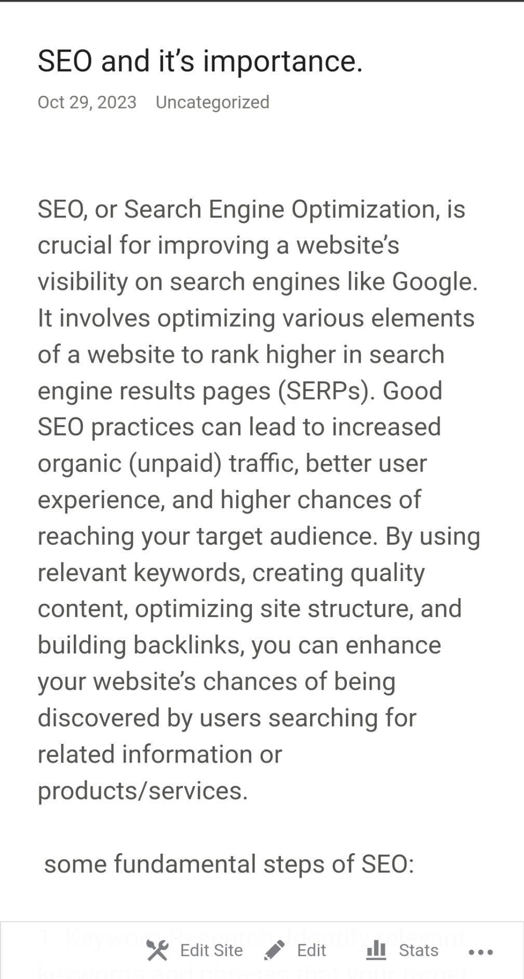

2.Create and design a social media advertisement poster using canva.

[https://searchengineoptimization023.blogspot.com/2023/09/how-we-](https://searchengineoptimization023.blogspot.com/2023/09/how-we-are-doing.html)

[aredoing.html](https://searchengineoptimization023.blogspot.com/2023/09/how-we-are-doing.html)

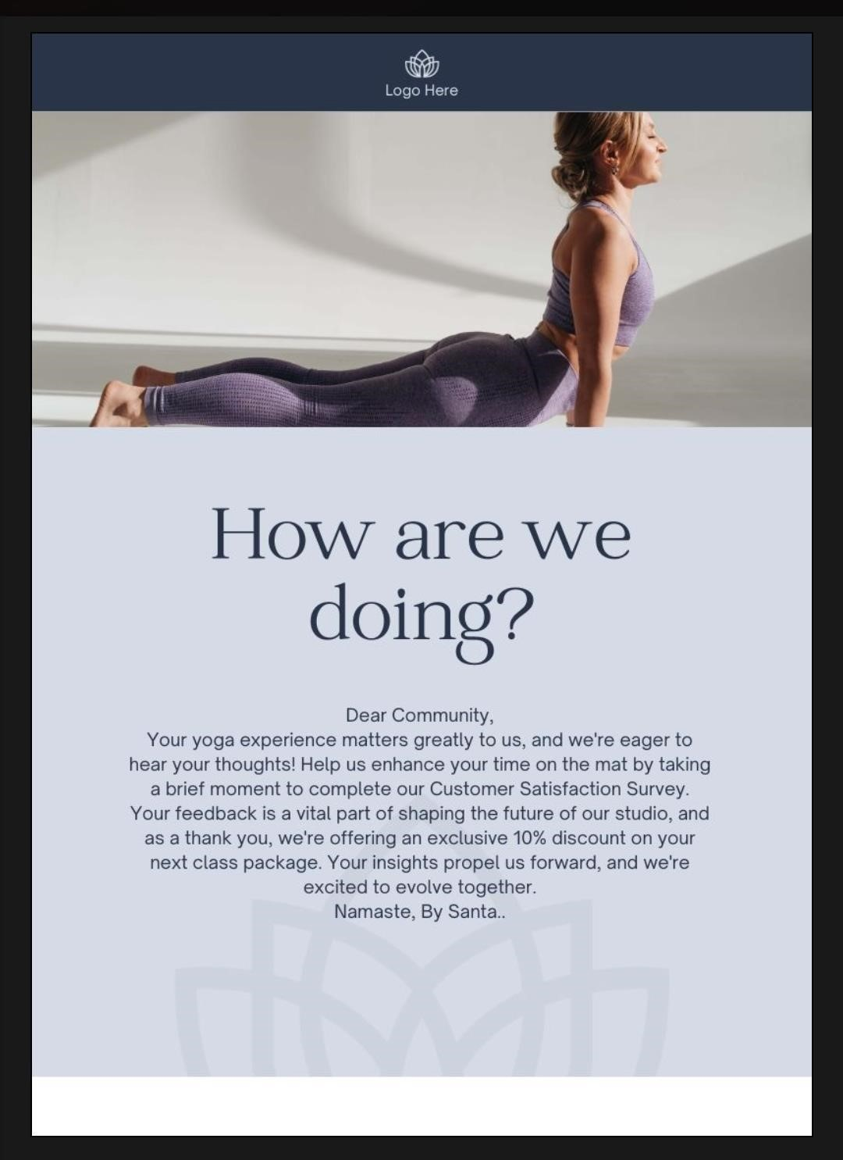

Create email newsletter design using Mailchimp or canva tool

[https://searchengineoptimization023.blogspot.com/2023/09/timelinedesignprocessing.html](https://searchengineoptimization023.blogspot.com/2023/09/timeline-design-processing.html)

